Spike: Spike 37
Title: 2D Drawing

Author: Rachel McQueenie 696737x

Goals / deliverables:
- An application that can load and display multiple images, including sub-regions of one image onto another
  - Display a single image as the background image, which can be toggled on and off with the '0' key
  - Load another image that contains three identifiable sub-regions within it
  - Three rectangles that specify the sub-regions which can change their position to a random location using the '1,' '2,' and '3' keys

Technologies, Tools, and Resources used:
- Windows 7
- Visual Studio Professional 2012
- SDL Wiki: SDL 1.2 to 2.0 Migration Guide
  - http://wiki.libsdl.org/MigrationGuide
- SDL Wiki: SDL_BlitSurface
  - http://wiki.libsdl.org/SDL_BlitSurface
- Lazyfoo: Getting an Image on the Screen
  - http://lazyfoo.net/tutorials/SDL/02_getting_an_image_on_the_screen/index.php
- Buckys C++ Programming Tutorials - 27 - Random Number Generator
  - http://www.youtube.com/watch?v=naXUIEAIt4U

Tasks undertaken:
- Obtain two Bitmap images. They do not need to be fancy. I just used two of my own photos.
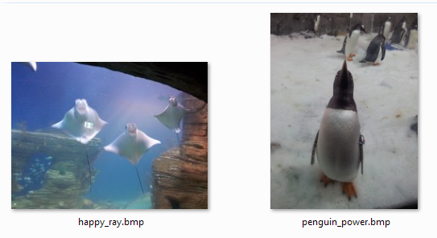
- Open up Visual Studio and create a new project.
- Download and install SDL 2, then link it to your project. Refer to Spike 35 if you are unsure how to do this.
- Include the following in your .cpp file:
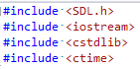
- Define constants for the screen dimensions:
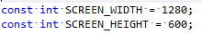
- Set up the random generator seed using time so that we get some unique numbers on each runtime
- Initialise SDL. Always check to see if it initialised correctly (should return 0 if it initialises properly, or -1 if it does not)
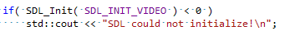
- Set up your variables for the event handler and loop
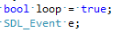
- Set up your surfaces and window
- Load your Bitmap files
- Set up the code for the random number generator. Use the modulus operation to ensure it returns a number within the screen dimensions.
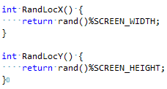
- Set up your rectangles
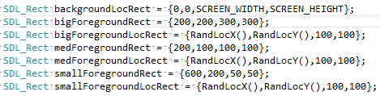
- Check if the background and foreground images loaded properly
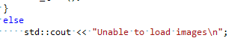
- Set up your boolean for checking if the background has been toggled on or off
- Set the screen surface to use the window so that we can see what is being rendered
- Set up loop and event poll. For more information event polling, refer to Spike 36.
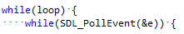
- Check if the program as been quit by pressing the 'X' button on the window or the 'a' key
- Check if a key has been pressed
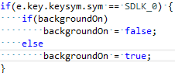
- If '0' has been pressed, toggle the background on or off

- If '1' has been pressed, change the location of the big foreground image. Change its previous area to fill with black, otherwise we will still have the original picture when we redraw it at its new location
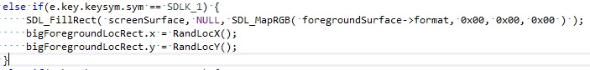
- If '2' has been pressed, do the above but for the medium sized foreground image
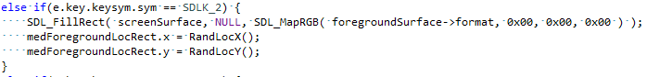
- If '3' has been pressed, do the above but for the small sized foreground image
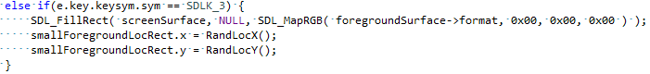
- Redraw the content
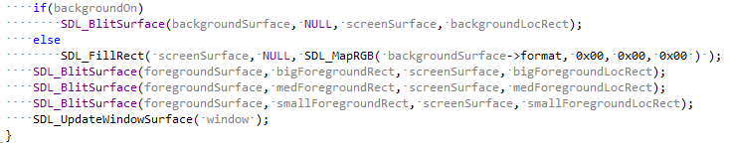
- Free the surfaces, destroy the window and quit
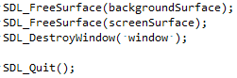
- Return 0 to complete the application
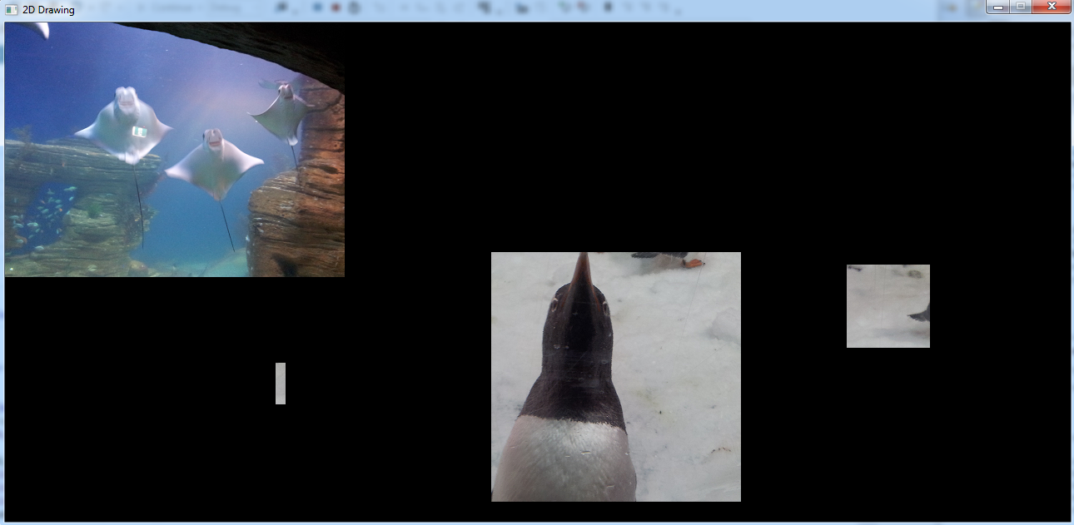

What we found out:
- How to import a Bitmap image from a file, as demonstrated in Step 10
- That toggling the background on and off involved filling the area with something else in its place, then redrawing. In this case, I used a black, filled rectangle. To bring the background image back I simply used the SDL_BlitSurface function once more. Initially I had tried deallocating the memory and reallocating it, among other things, to try and get this working but this not only was the only method I could get working. The main benefit to this, however, is that it is a simple solution that is also safe because it does not involve deallocating memory or any other function which may cause problems down the track.
- The simplest way to display the changes is to separate the calculations and the rendering (akin to the concept of Input, Update and Render from earlier Spikes). For instance, when drawing a moved foreground image, you first re-assign the position values in the rectangle, then use another SDL_BlitSurface to redraw the image using the new rectangle location.
- To ensure you get a random number to be within the dimensions of the screen, use a modulus operation.

Recommendations:
- Refactor the code, as the main function is fairly big and messy. There was some repeated code, such as the SDL_BlipSurface calls that could have been extracted into a new function, for instance. However, it was beyond the scope of this Spike so I did not bother.
- Perhaps work out a way to fill the screen with the background image, as at the moment it only takes up a small portion of it.

